Ryan Shipman

Dec 16, 2020

IT FDN 110 A

Assignment09

<https://github.com/RyShip/IntroToProg-Python-Mod09.git>

Working With Modules

**Introduction.**

This will be a very brief document on the concepts I used in module 09. I won't be explaining how I wrote my main file, rather I will be explaining concepts that I learned and helped me understand how to write the main executable file for this assignment. Lets jump in.

**Modules**

Modules in python refer to a file containing statements, definitions, classes, functions and methods. You can use modules to break down large programs into small manageable sections and keep them organized.

This was the basic idea behind the assignment for this module. For instance there were three different files (or modules) for the user IO, processing, and data.

* DataClasses.py
* IOClasses.py
* ProcessingClasses.py

**Main.py**

Now you're probably wondering how you run the program if you're managing multiple files (modules) within your program. Well applications in python are run from one of the files directly. You would import any other modules you would want the main to run at the beginning of the main module. Reference figure 1.

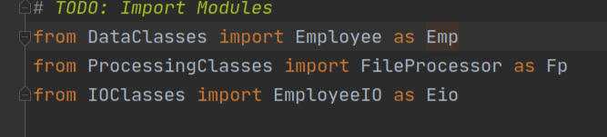

Figure 1.

You can use the ‘__name__’ system variable to verify that a script is running as the main module. See figure 2 for how that would look.

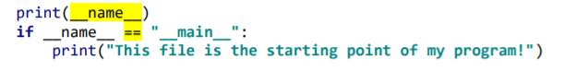

Figure 2.

You can als raise an exception while using ‘__name__’ to let yourself know if you are working with the main module or any other special requirement. See figure 3 for how that might look.

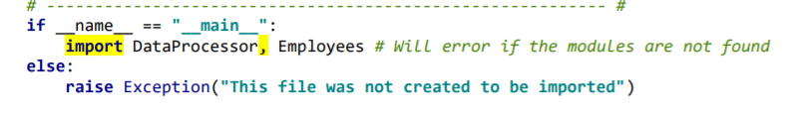

Figure 3.

Now linking the modules together is very simple, it is a lot like calling a class or function. See figure 4 for how the syntax looks. You just have to make sure you import the other modules at the beginning of your main module. You can also import just a certain class from said module if you don't need the whole module imported see figure 5 for how the syntax would look for that.

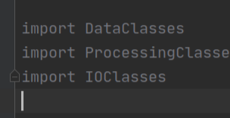

Figure 4 importing the modules

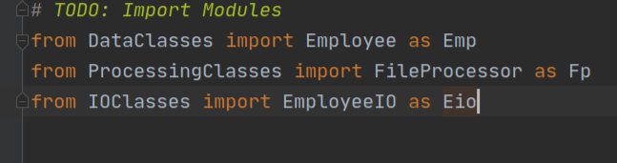

Figure 5. Importing just the class from a module.

Figure 6 will be the entire script from my main file in my program.

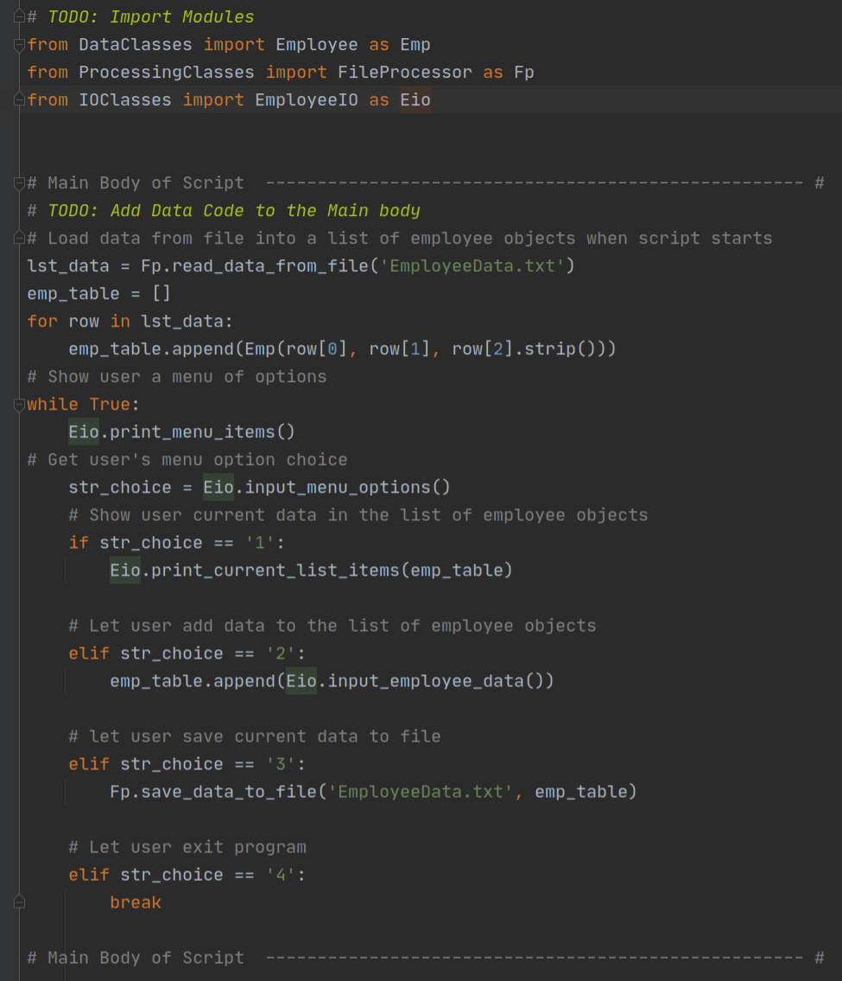

Figure 6. Main script module.

**Summary**

These are some of the main concepts we learned in this module which allowed me to complete the assignment. Foundational knowledge I can use in my career. I hope these concepts will also help you as well. C’ya.